|  |  |
| --- | --- |
| **NAME** | Manvith BV |
| **REG NO** | 311520104031 |
| **CLASS** | B.E-CSE |
| **EMAIL ID** | [Manvithbhoomi@gmail.com](mailto:Manvithbhoomi@gmail.com) |
|  | **ASSIGNMENT - 2** |

|  |  |
| --- | --- |
| **Task** | Upload the dataset to Cognos Analytics, prepare the data, explore and create Interactive Dashboard, report and Story |
| **Problem Statement:-** | |

HR data can be hard to come by, and HR professionals generally lag behind with respect to analytics and data visualization competency. We use the data set to teach HR students how to use and analyze the data in Cognos - a data visualization tool that'seasy to learn.

Output:-

Overall Dashboard

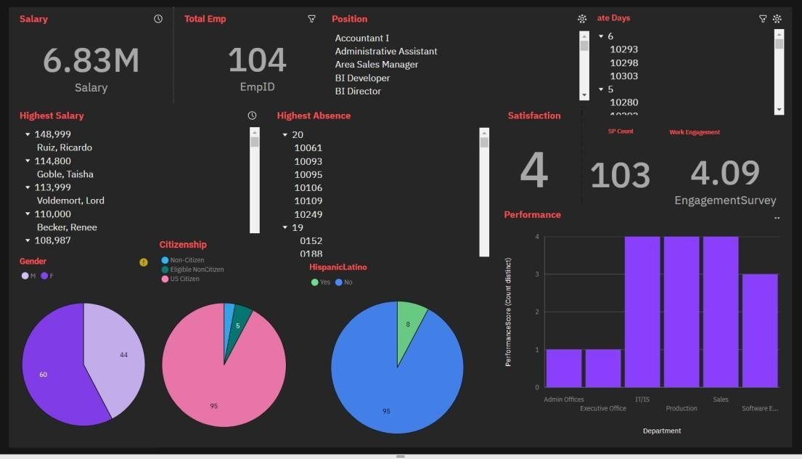

Female Employees

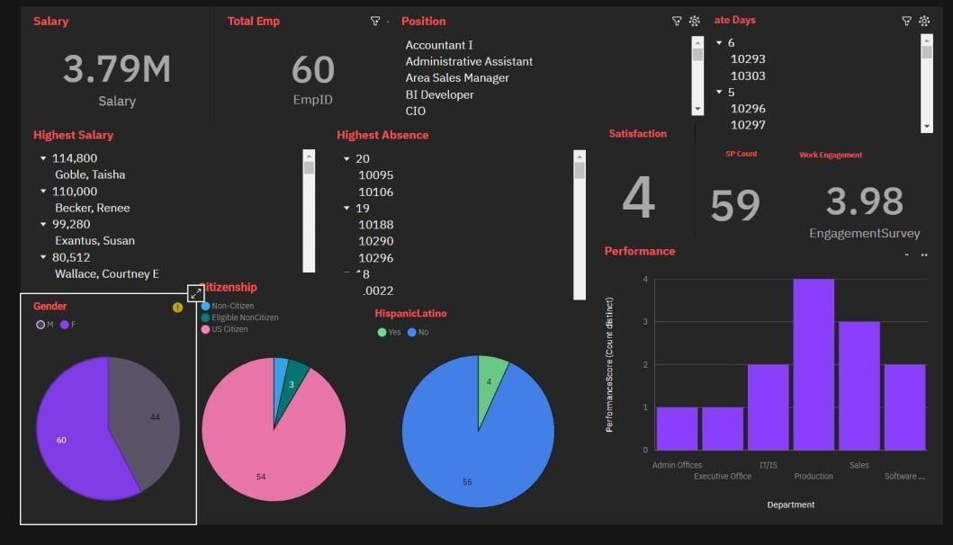

Male Employees

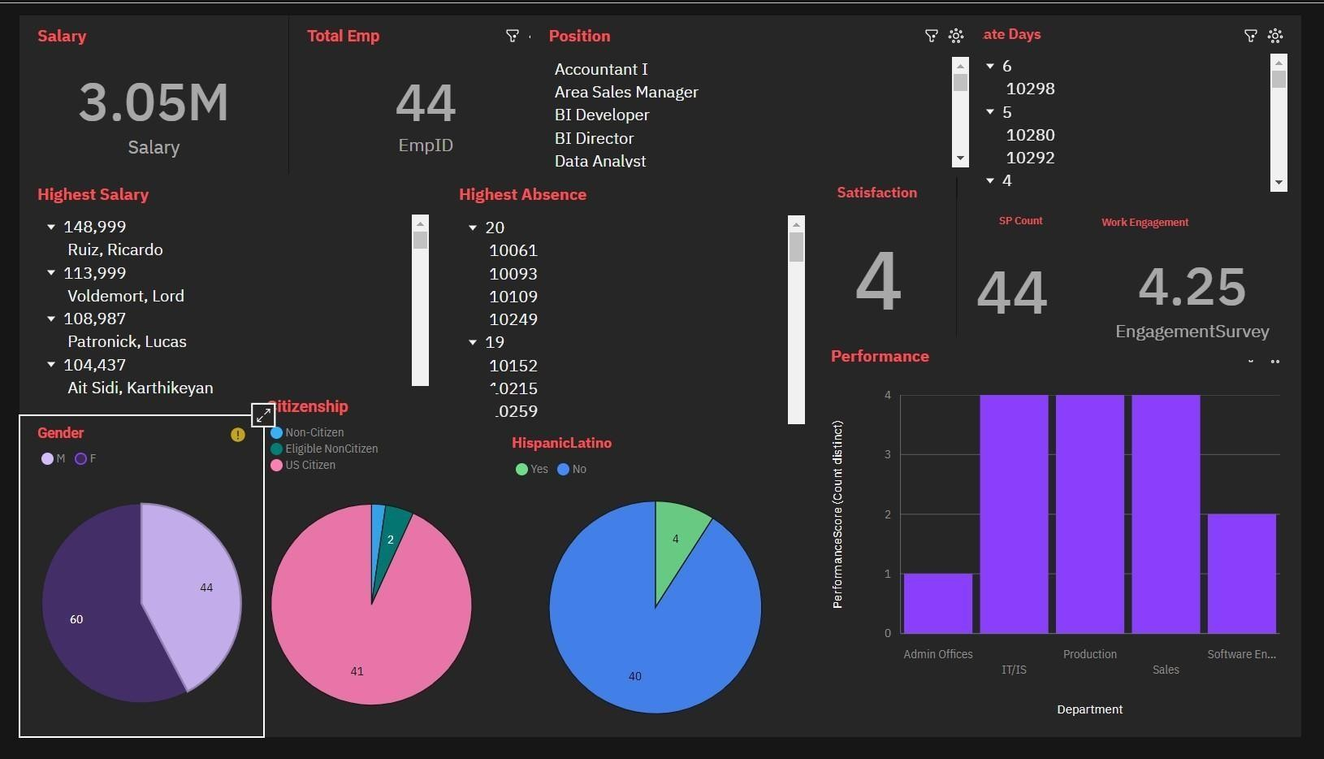

Data Analyst Employee

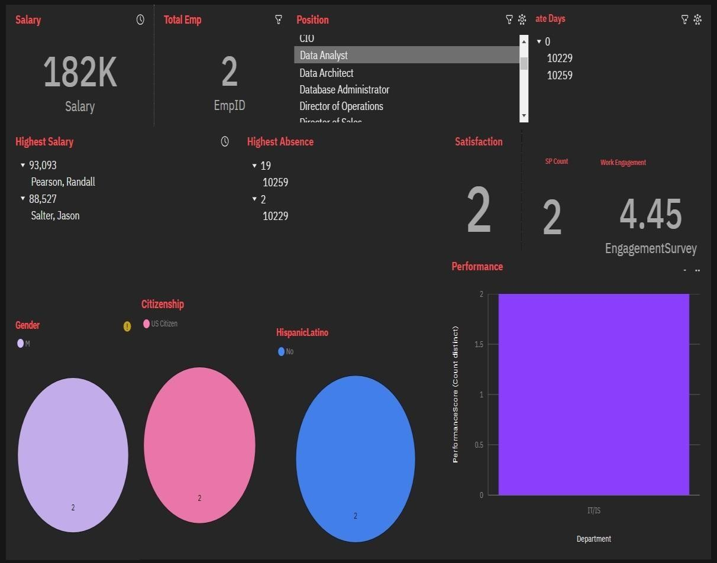

US Citizen Employees

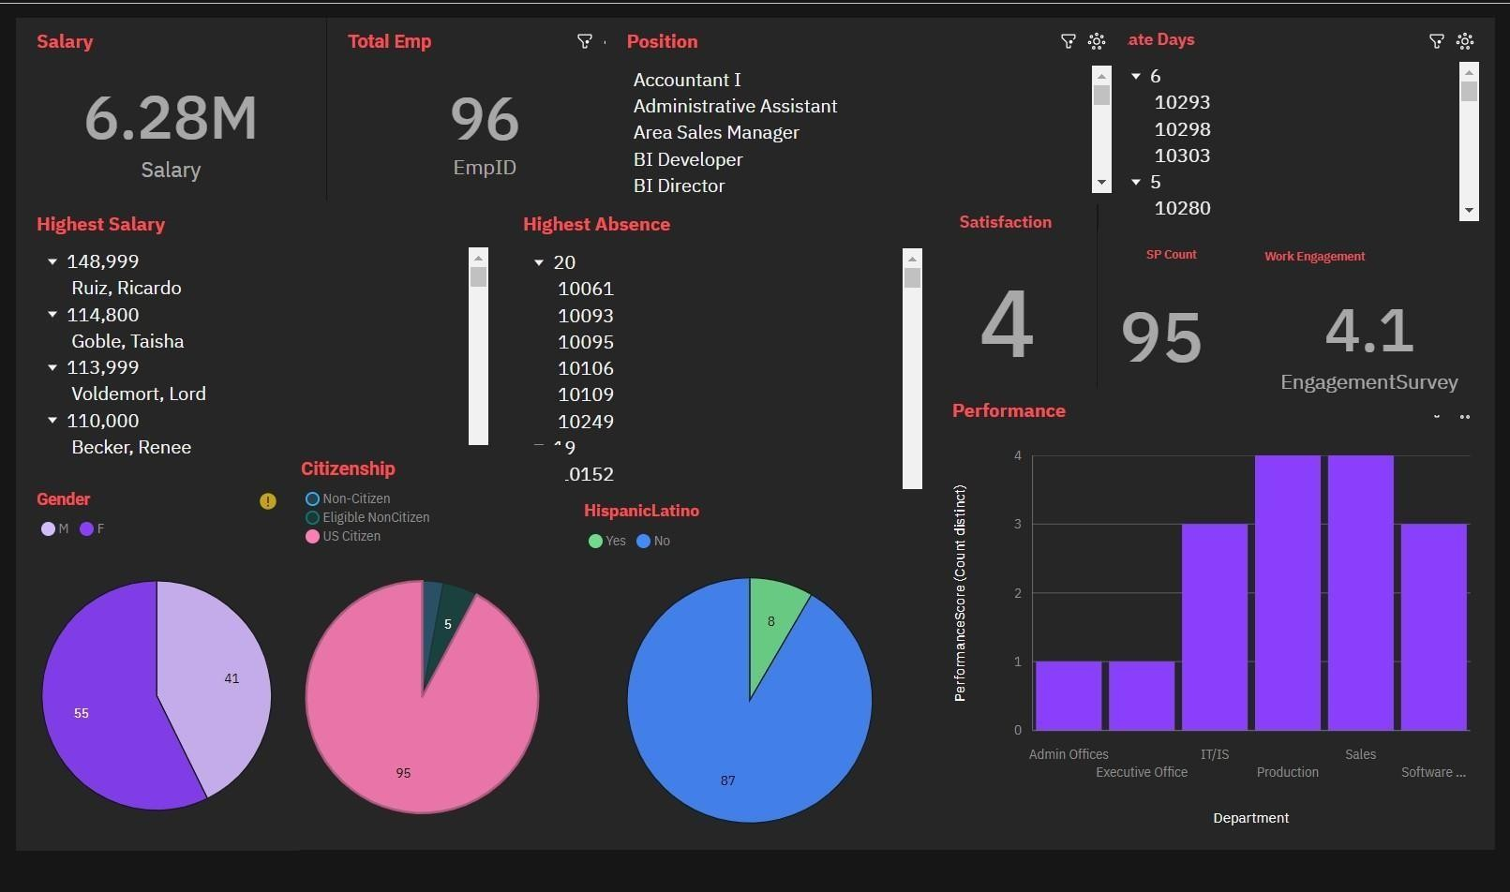

Search with Marital Staus

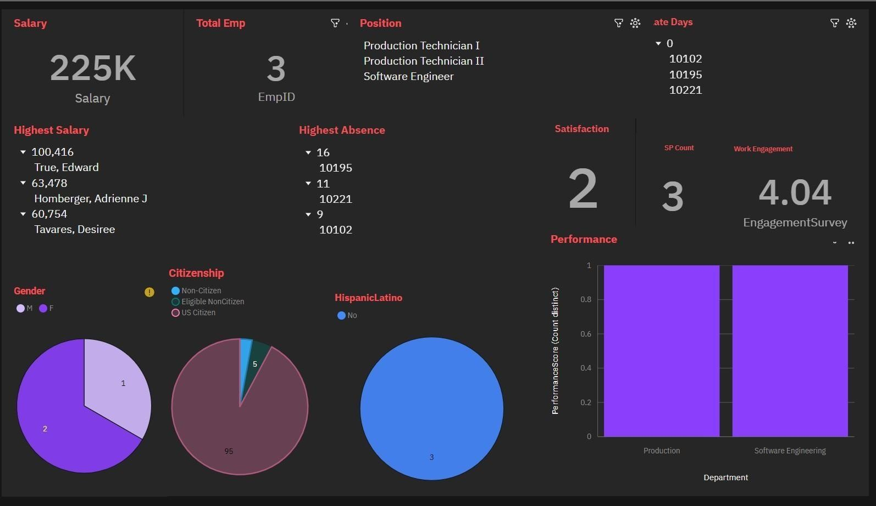

Eligible Non Citizen Employees

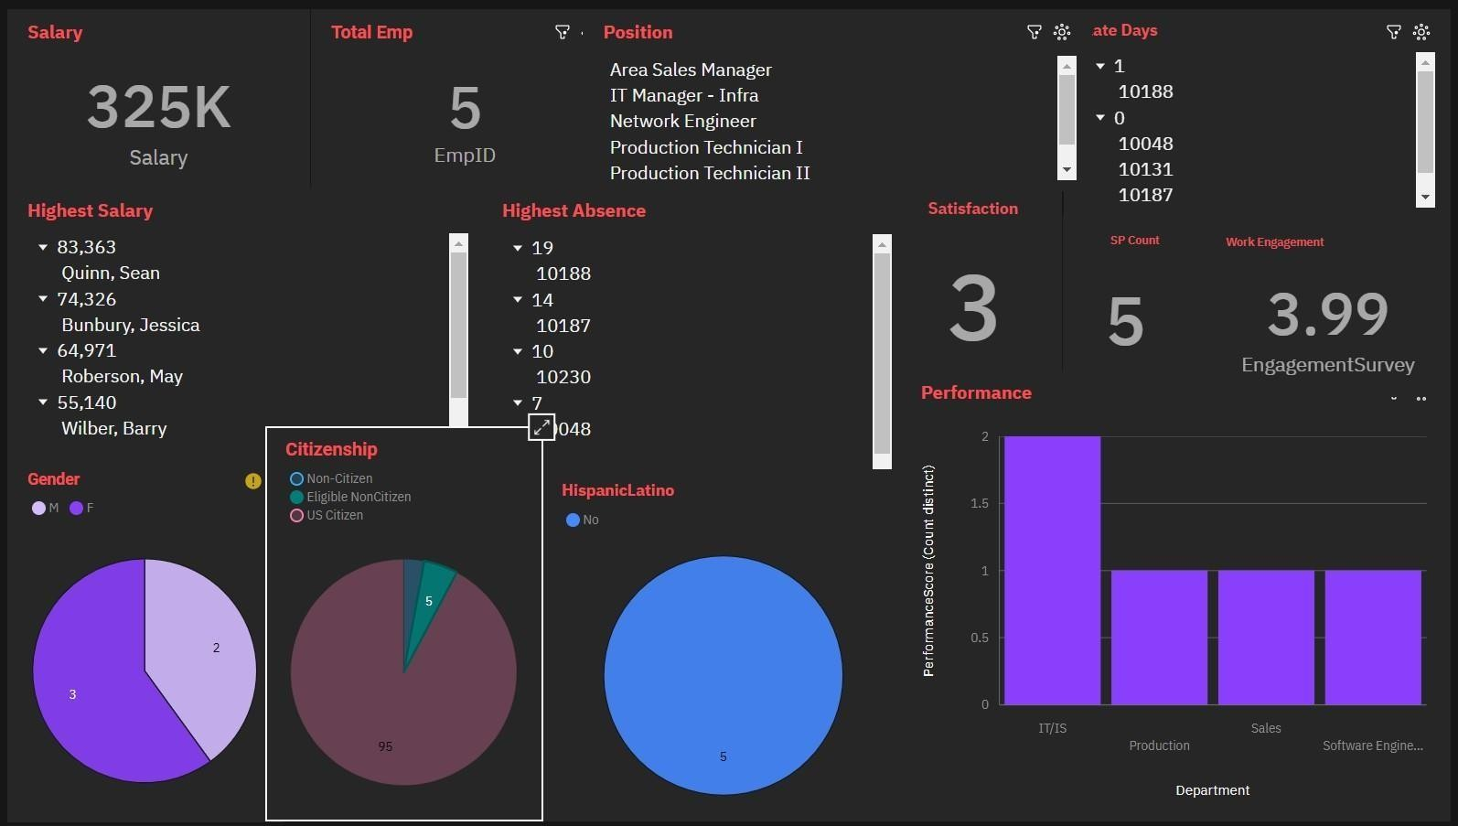

Search Dashboard

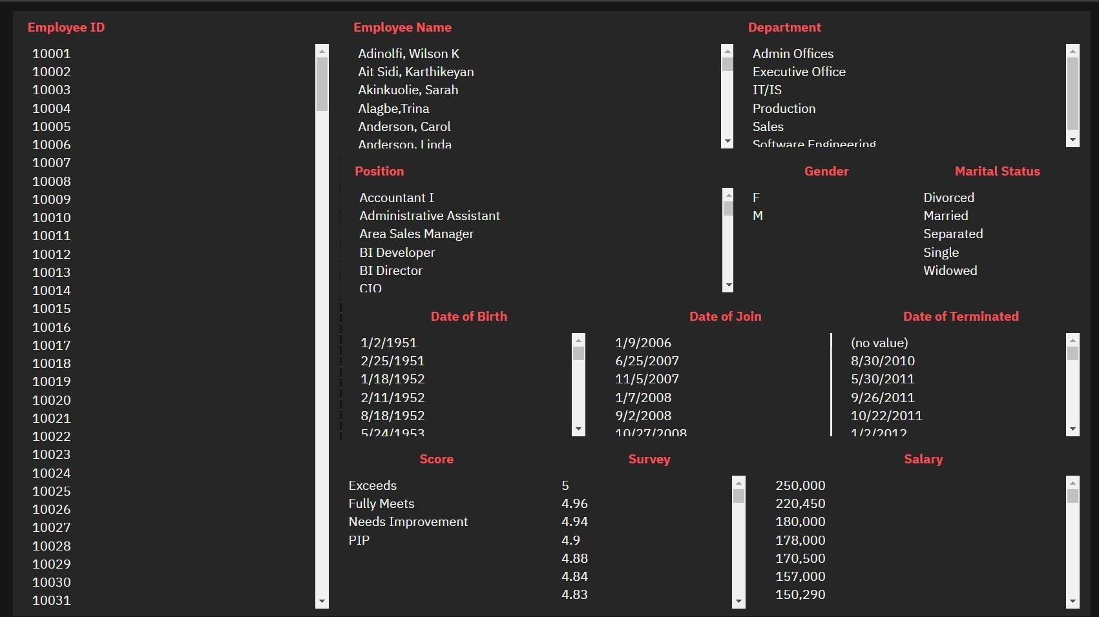

Search with Employee ID

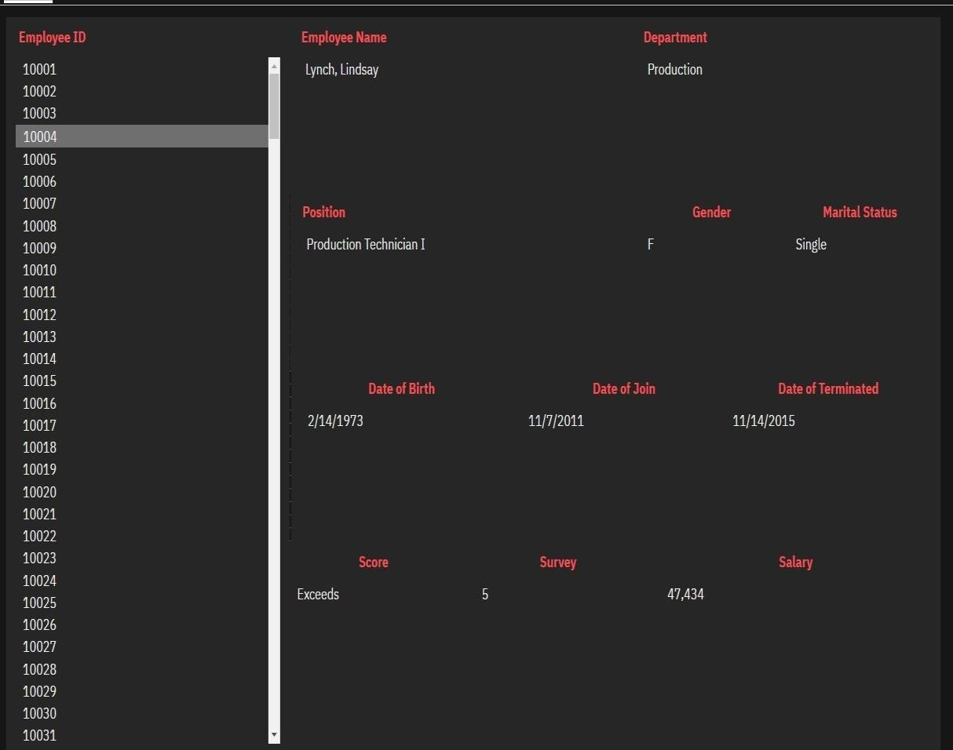

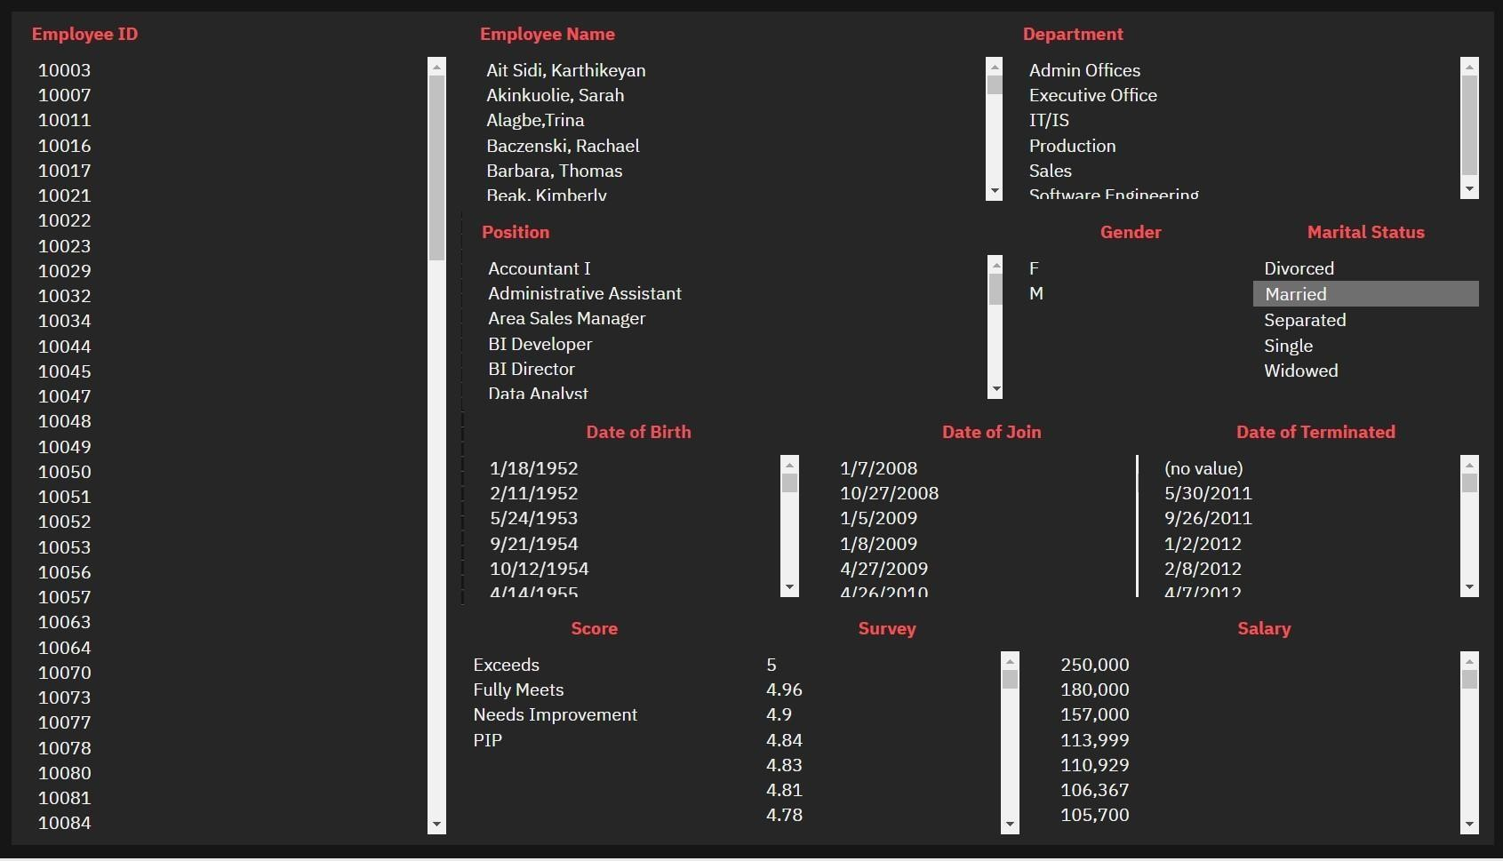

Search with Performance Score

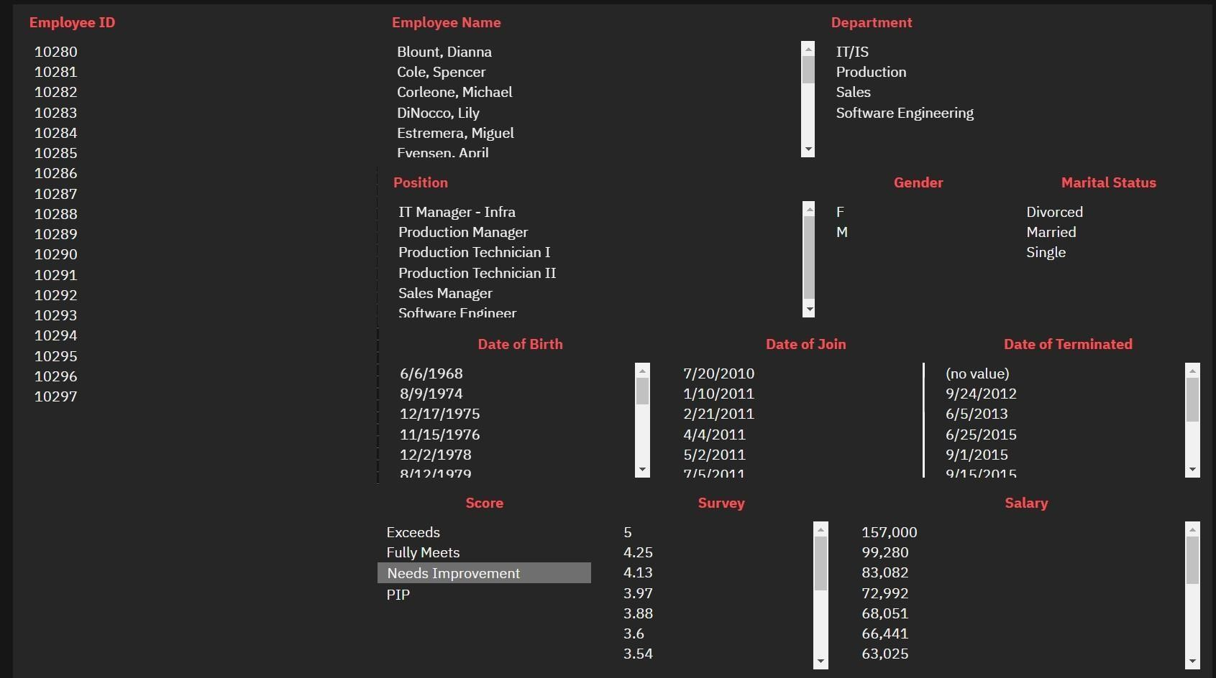

Search with Survey Performance and Department

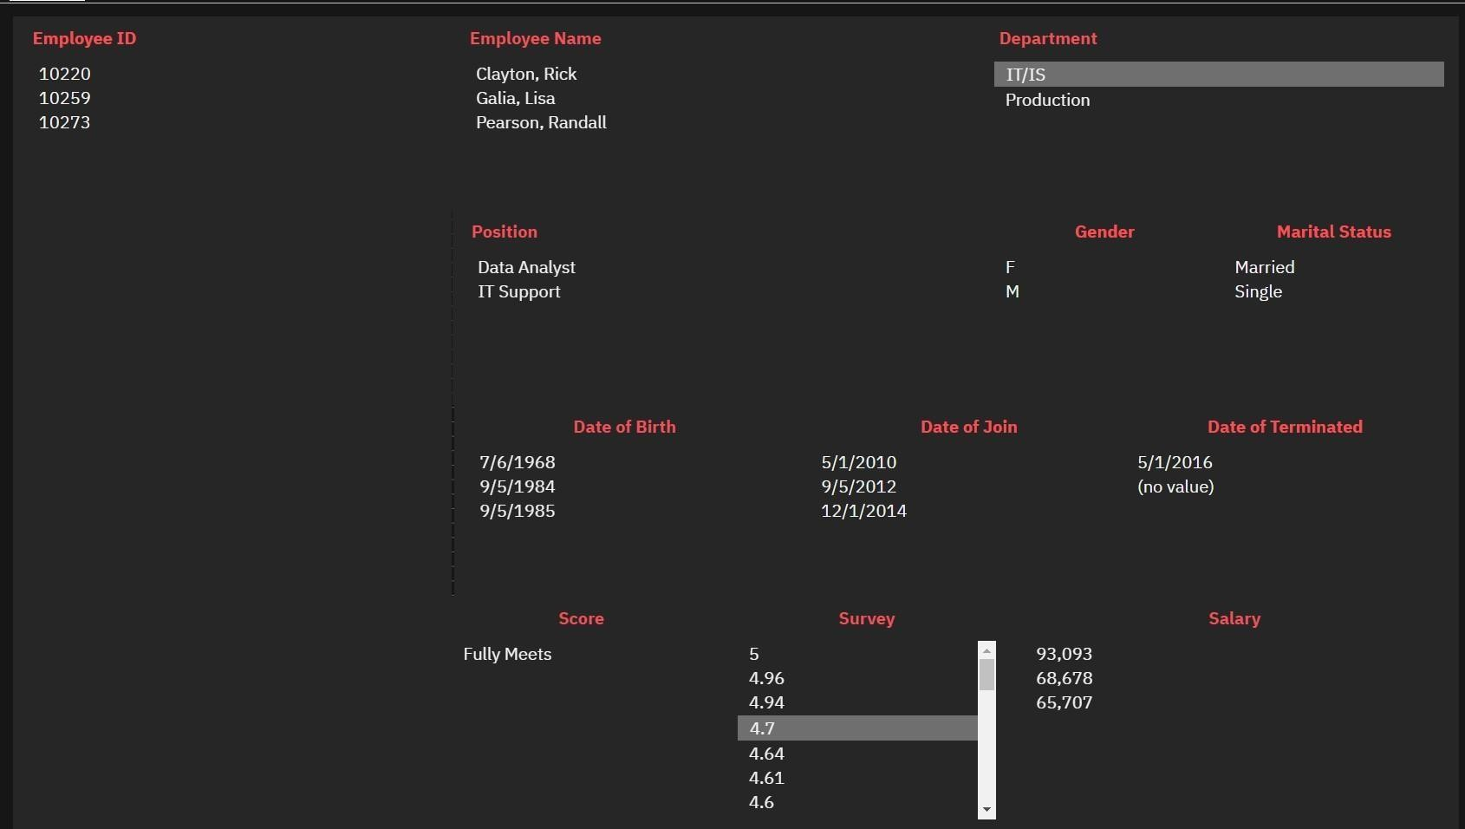

Search with Multiple Attributes

